The first sign of VPN connection issues use:

NETSH INT IP RESET c:\resetlog.txt

IPCONFIG /RENEW

If is still does not connect

1. Navigate to this location:
   * ComputerHKEY_LOCAL_MACHINESYSTEMCurrentControlSetServicesPolicyAgent
2. Right-click on the blank area in the right window and select New > DWORD.
3. Name the new DWORD input

AssumeUDPEncapsulationContextOnSendRule

1. Change its value to **2** and save it.
2. Close Registry Editor and restart your PC.
3. Type **Control** in the Windows Search bar and open **Control Panel** from the list

[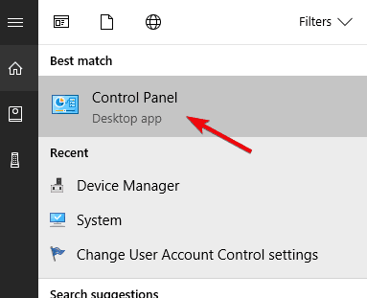](https://cdn.windowsreport.com/wp-content/uploads/2018/02/windows-10-vpn-not-working-after-update-11.png)

1. Open **Network and Internet** and then **Network and Sharing Center**.[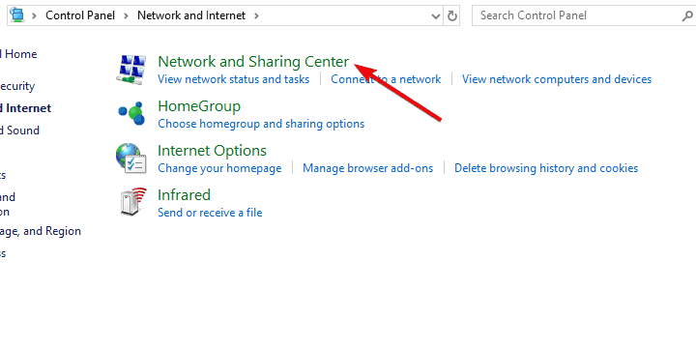](https://cdn.windowsreport.com/wp-content/uploads/2018/02/windows-10-vpn-not-working-after-update-1.png)
2. Select **Change adapter settings** from the left pane.[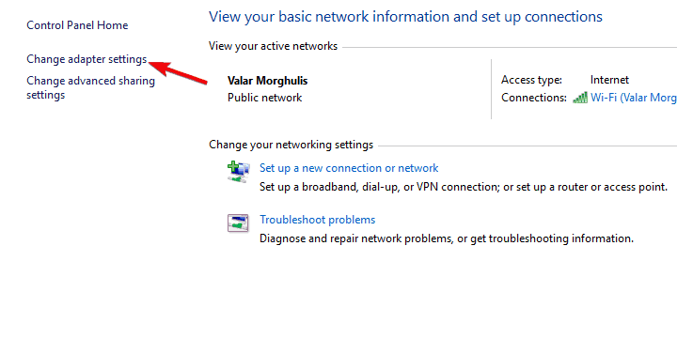](https://cdn.windowsreport.com/wp-content/uploads/2018/02/windows-10-vpn-not-working-after-update-2.png)
3. Right-click on **VPN network adapter** and open **Properties**.[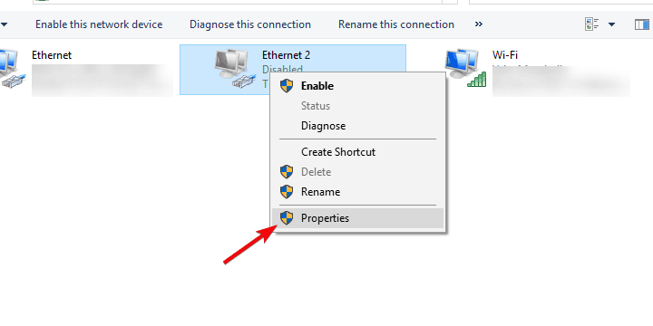](https://cdn.windowsreport.com/wp-content/uploads/2018/02/windows-10-vpn-not-working-after-update-6.png)
4. **Uncheck** the box beside IPv6 and confirm changes.[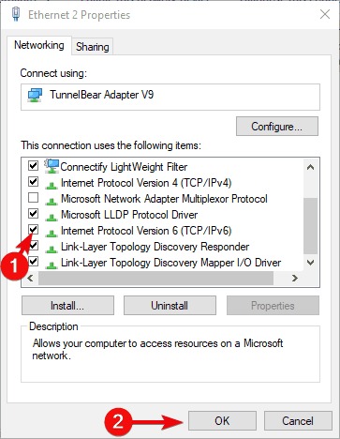](https://cdn.windowsreport.com/wp-content/uploads/2018/02/windows-10-vpn-not-working-after-update-15.png)
5. Try running a VPN afterward.

If you have the device in front of you

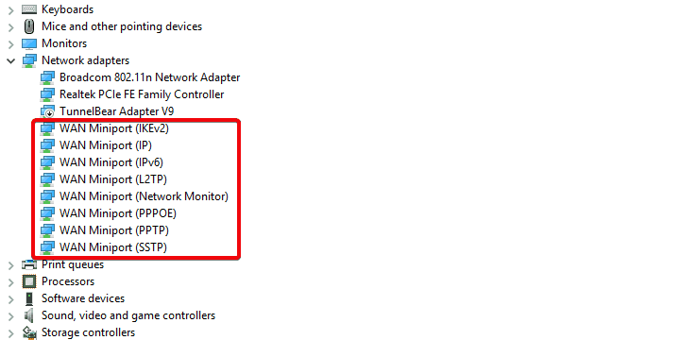

Uninstall each one of these, then reinstall each one